# PROJECTS

## Tourist Website

### A Captone Project

*01/2021 - 04/2021*,

*Speciﬁcs*

In this Captone project, I developed a website that can be used by tourists while travelling to Kashmir

The key features are, user can book the cab, book the hostel,

# SKILLS

Java

Python

MySql

HTML

Javascript

C#

CSS

Networking

Node JS

React

**EDUCATION**

can use map fortravelling from one destination to other, can

see the review of other tourists about the destination.

## Attendance Stimulator

### GUI

*02/2018 - 05/2018*,

*Speciﬁcs*

It calculates the attendance of students by taking few inputs

Takes inputs like total classes conducted, classes attended etc and provided output of attendence percentage and required classes to attend to prevent detention.

#### Lovely Professional University (07/2017 - 08/2021)

Bachelor of Computer Science & Technology (CSE) CGPA: 7.91

#### GHSS Khanda Budgam (04/2015 - 01/2017)

12th Standard Percentage : 81%

#### JNV Budgam, Srinagar (04/2014 - 03/2015)

10th Standard CGPA - 9.0

# WORK EXPERIENCE

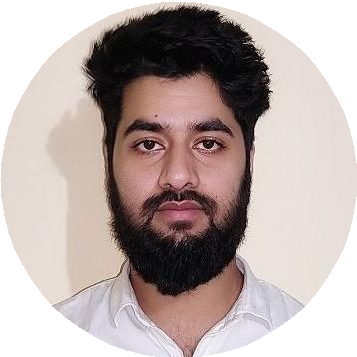

[linkedin.com/in/aamirshabir856](https://linkedin.com/in/aamirshabir856)

Srinagar, India

+91-7006110290

[Shabiramir31@gmail.com](mailto:Shabiramir31@gmail.com)

Aamir Shabir

Software Engineer

A motivated engineer with extensive training in various coding languages, frameworks, and building web applications from the ground up. Specialized in Java and C#. Strong troubleshooting and problem-solving skills with an analytical mindset. Solid written and verbal communication, and time management skills.

## Programee Analyst Trainee

### Cognizant Technology Solutions (CTS)

*12/2021 – Present*, *Bangelore, India*

*Achievements/Tasks*

Worked on RPA technology

Project Tracking System using mainspring- as developer

# INTERNSHIPS

#### Cognizant Technology Solutions (CTS) (03/2021 - 08/2021)

*Build a module of medicine maintainance website using .Net framework.*

Lead college Cricket team

#### NIIT Srinagar (06/2019 - 07/2019)

*Trained in PHP programming for frontend and MySql for backend designing. Build a Shopping website.*

# LANGUAGES

English

*Full Professional Proﬁciency*

Urdu

*Native or Bilingual Proﬁciency*

# ACHIEVEMENTS

Received Best student Award

Secured 3rd rank in State Math Olympiad

Hindi

*Full Professional Proﬁciency*

Kashmiri

*Native or Bilingual Proﬁciency*